Jenkins CLI and log enablement

Steps to work with Jenkins and its services

Goto EC2 >> boot jenkins service - service jenkins restart >> open browser >> <http://public-ip:8080>

>> service jenkins status >> stopped will need log verification

Steps to check Jenkins and logs

Goto /var/log/jenkins/jenkins.log ……Displays the no such file or directory

Home directory of jenkins:

Goto /var/lib/jenkins/logs ……Displays health checker logs; not the right one

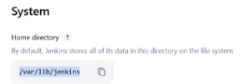

Goto /var/log ……Displays all app logs

Goto /var/lib/jenkins ……Displays jenkins app location and files

* Config.xml ……Displays jenkins configuration

Goto Google >> Jenkins log file location ……Displays search

Goto - systemctl edit jenkins

* Append logfile location manually under [Service] tab ……Permissions denied to root



Goto new directory:

* Sudo vim /etc/systemd/system/jenkins.service.d/override.conf
* Mkdir -p /etc/systemd/system/jenkins.service.d
* Vim override.conf



* Sudo systemctl daemon-reexec
* Sudo systemctl daemon-reload
* Sudo systemctl restart-jenkins
* Tail -f /var/log/jenkins/jenkins.log ……Displays logs finally
* Service jenkins ……Displays all possible command

Steps to work with installed plugins

Goto - /var/lib/jenkins/plugins

* Cd ..
* Wget github version source_code.zip by right clicking and copying the desired plugin, and get the name of the plugin from jenkins plugin index
* Sudo mv “plugin-name.hpi” /var/lib/jenkins/plugins
* Sudo chown jenkins:jenkins plugin-name.hpi ……Ready to download plugin
* Sudo chmod 644 plugin-name.hpi
* Sudo systemctl restart jenkins

Sample links - <https://github.com/jenkinsci/gcp-secrets-manager-credentials-provider-plugin>

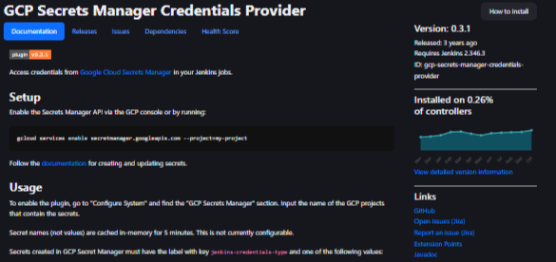

Steps to check Jenkins logs

* Service jenkins status ……displays jenkins is running
* Service jenkins stop ……intentionally stop and analyze stopped logs
* Service jenkins status ……displays jenkins is inactive. Don’t start, but analyze logs
* Cd /var/log/jenkins/jenkins.log ……no such file or directory, can be mentioned at interviews for reference
* Cd /var/lib/jenkins/logs ……displays the healthchecker logs, we need server logs

>> Default log location of every app/server 🡪 /var/log ……enable jenkins log here as well

>> Common locations to check 🡪 /var/lib/jenkins & ~/.jenkins/

>> Still not available as the displayed ones are component logs, to view main jenkins logs:

* Sudo journalctl –u jenkins –f ……displays realtime log, but no updates on it as service is in stopped state

>> Ways of troubleshooting log:

* Start jenkins >> Manage jenkins >> system log >> log recorder ……not here
* Google “jenkins log file location” >> <https://www.jenkins.io/doc/book/system-administration/viewing-logs/> ……jenkins documentation log location, not here
* Chatgpt tells to check 🡪 /home/jenkins ……not here

>> Check and redirect:

* Sudo systemctl edit jenkins
* Add  …… Permissions denied to root
* Enable user to edit jenkins file
* 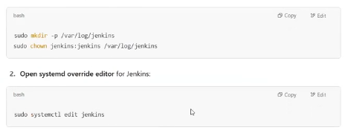
* systemctl edit jenkins ……does not allow to edit the file

>> Open the config file(ctl jenkins named as override.conf) using VIM

>> Goto new directory:

* Sudo vim /etc/systemd/system/jenkins.service.d/override.conf
* Mkdir -p /etc/systemd/system/jenkins.service.d
* Vim override.conf

>> Add the lines:

* [Service]
* StandardOutput=append:/var/log/jenkins/jenkins.log
* StandardError=append:/var/log/jenkins/jenkins.log

>> Restart daemon and service

* sudo systemctl daemon-reexec
* sudo systemctl daemon-reload
* sudo systemctl restart jenkins

My understanding

show me service tab to add log file location lines of jekins in override.conf with locations in chatgpt

>> To configure Jenkins to log to a specific file location using systemd, you can create or modify the override.conf file for the Jenkins service. Here's how you can do it:

### >> Step 1: Create or Edit the override.conf File

1. **Open a terminal** on your Jenkins server.
2. Run the following command to edit the Jenkins service configuration:

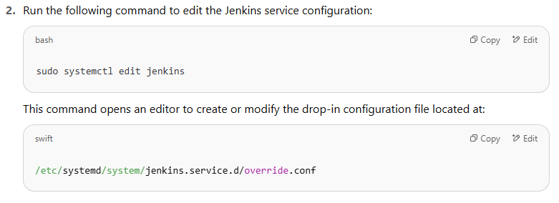

### >> Step 2: Add Environment Variable for Log File Location

In the editor, add the following lines to specify the desired log file location:

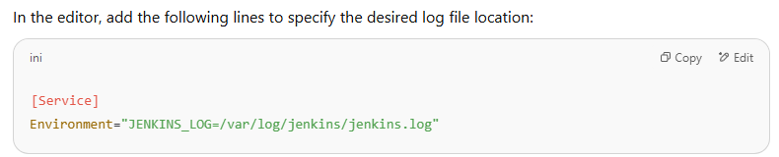

Replace /var/log/jenkins/jenkins.log with your preferred log file path.

### >> Step 3: Reload Systemd and Restart Jenkins

After saving the changes:

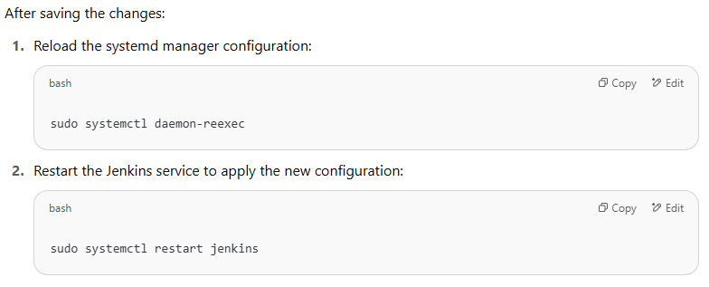

>> Notes

